**Pizza sales query**

**KPI’S THAT SOLVED**

1.Total Revenue

select sum(total_price) as Total_Revenue from pizza_sales

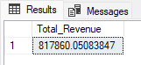

2.Average Order Value

select SUM(total_price)/ COUNT(DISTINCT order_id) as Avg_Order_Val from pizza_sales;



3.Total pizza sold

select SUM(quantity) as total_pizza_sold from pizza_sales;



4.Average pizza per order

select CAST(CAST(SUM(quantity) as decimal(10,2))/CAST(COUNT(distinct order_id) as decimal(10,2))as decimal(10,2)) as pizza_order

from pizza_sales;



**CHART REQUIREMENT**

1.Daily trend For Total Orders

select DATENAME(dw,order_date) as Order_days,

COUNT(distinct order_id) as total_order

from pizza_sales

group by DATENAME(dw,order_date);

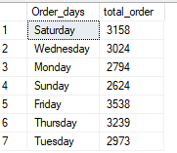

2.Hourly Trend For Total Orders

select DATEPART(HOUR,order_time) as Order_time,

COUNT(distinct order_id) as total_order

from pizza_sales

group by DATEPART(HOUR,order_time)

order by DATEPART(HOUR,order_time);

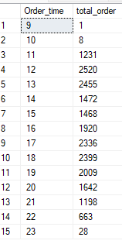

3.Percentage Of Sales By Category

select pizza_category, SUM(total_price)*100 / (select SUM(total_price) from pizza_sales) as precentage_category

from pizza_sales

--where MONTH(order_date) = 1

group by pizza_category;

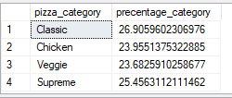

4. Percentage Of Sales By Size

select pizza_size, SUM(total_price)*100 / (select SUM(total_price) from pizza_sales) as precentage_size

from pizza_sales

--where MONTH(order_date) = 1

group by pizza_size;

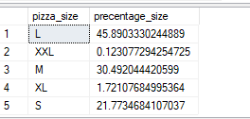

5.Total Pizza Sold By Category

select pizza_category,SUM(quantity) as Total_quantity_category

from pizza_sales

group by pizza_category;

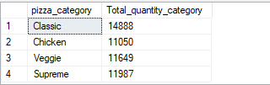

6.Top 5 Best Seller Pizza By total Pizza Sold

select top 5 pizza_name,SUM(quantity) as Top_sold_pizza

from pizza_sales

group by pizza_name

order by SUM(quantity) desc;

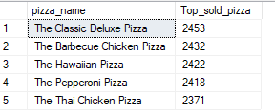

7.Top 5 Worst Seller Pizza By total Pizza Sold

select top 5 pizza_name,SUM(quantity) as worst_sold_pizza

from pizza_sales

group by pizza_name

order by SUM(quantity) ;

